Yahoo! Mail + Dropbox
Email attachments can be tricky: they’ve got file size limits, you can’t keep them updated, and when you add people to a thread, attachments are the first to get left behind.
The Yahoo! Mail team decided to fix this—by integrating with Dropbox! Starting later today, if you’re using a Yahoo! Mail account in English, French, German, Italian, or Spanish, you’ll be able to access your Dropbox from right inside your inbox. You can add stuff from Dropbox to any email message and save attachments back to Dropbox, too.
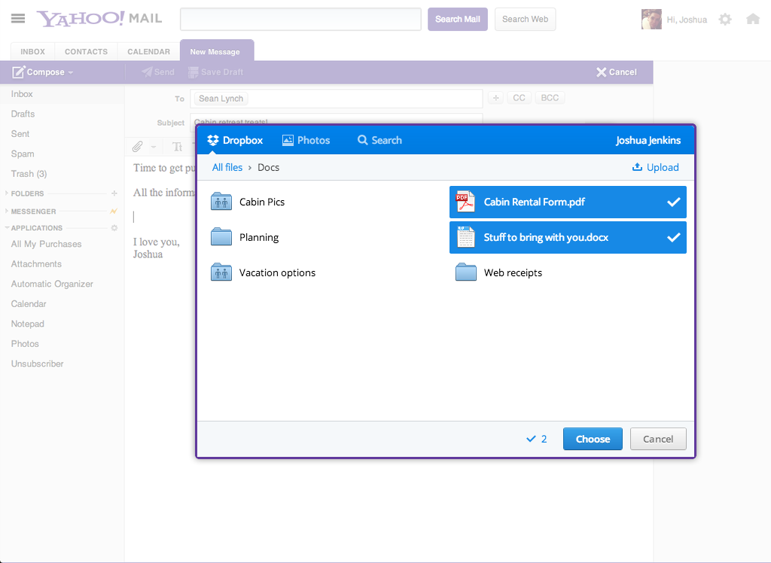
Since this integration is Dropbox-powered, you can even send that big album of vacation pics without worrying about the 25 MB file limit. Plus, it’s easy to save any photo, video, or doc in your Yahoo! Mail straight to your Dropbox, where you can get to it from anywhere.
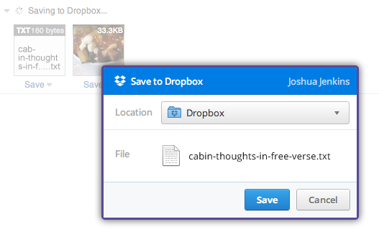
Head over to the Yahoo! Mail blog to learn more and then check it out for yourself

