Now we load the program each person depending on the system
First start the download here
Installation Method
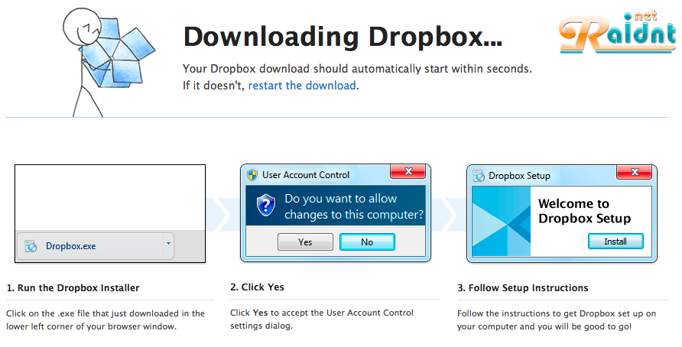
Installation Method
Move programs folder Alablkishn only
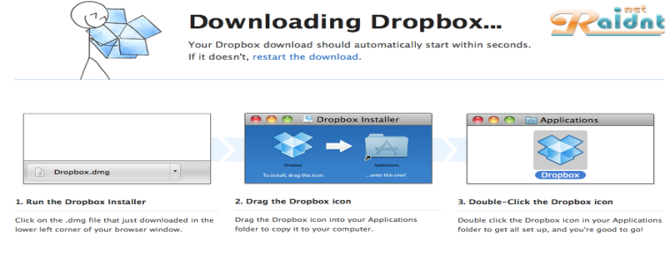
Systems Allyuncs from here
