Explain open a Dropbox account
From here we enter the site
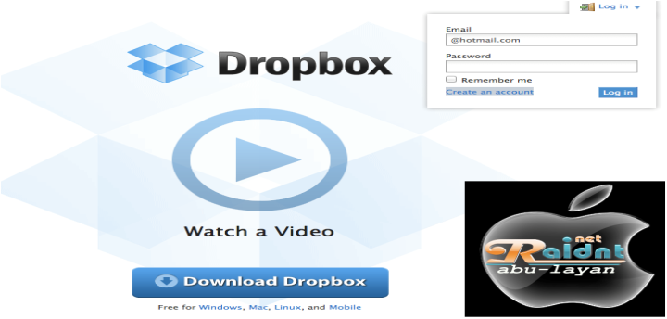
From the left menu log in choose Greate an account
Then we fill in the data: first name - last name - E - PIN - and then put the tick to agree to conditions
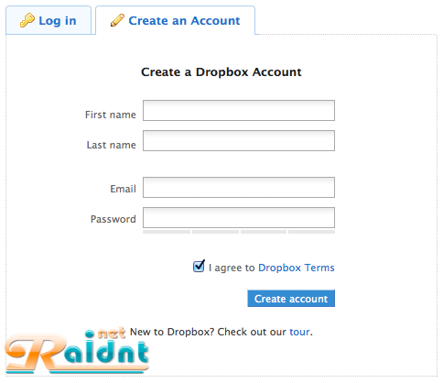
Congratulations account has been opened

