Drobpbox on the iPhone does the same work on the computer, but its additional features make it a multi-tasking program and the most important of these features the following:
1 - Review; and participation
2 - upload your files to your iPhone and run it directly without the need for the Internet.of all images and files

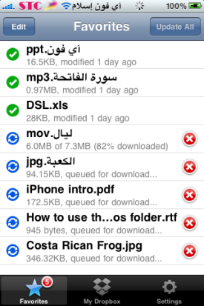
3 - Take a picture through the program and synchronized with Dropbox at the same Aellouk.
4 - run audio and video files stored in Dropbox
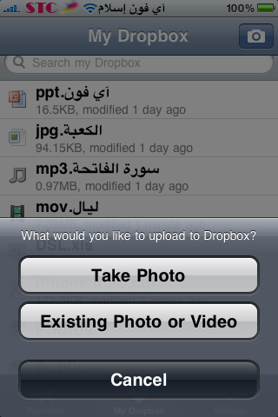

5-Review files ÇáĂćÝíÓ and pdf documents without the need for any additional program note that it supports Arabic language files
6 - sync audio and video files directly with Dropbox.
7 - to copy images to the clipboard links directly or sent by e-mail
8 - can put a pin number for the program on your iPhone in order to be away from the prying.
